Applied Research Report
Integrating Insecticide Seed Treatments, In-Furrow Insecticides, and Bt Traits to Manage Corn Rootworm, 2021
Authors
D. Tyler Mays, Extension Agent-IPM Hill and McLennan Counties
David Kerns, Extension Specialist-Entomology
Shane McLellan, County Extension Agent-Ag/Nr
Mike Berry, County Extension Agent-Ag/Nr
Zach T. Davis, County Extension Agent-Ag/Nr

Cooperator
Benjamin Volleman
David Westerfeld
Summary
Corn rootworm is a major pest of corn, especially in continuous corn operations. Current management options include crop rotation, Bt trait packages, insecticide seed treatments, and in-furrow insecticide applications. Two field trials were conducted to evaluate how integrating Bt trait packages with insecticide seed treatments and in-furrow insecticides perform in controlling corn rootworm in Central Texas. Three different Bt trait packages; a non-Bt, SmartStax, and Agrisure 3011A were planted without any additional treatment, Poncho 500, and Poncho 500 plus Capture LFR applied in-furrow. The SmartStax trait package alone, with Poncho 500, and with Poncho 500 plus Capture LFR applied in-furrow significantly reduced the amount of corn rootworm damage compared to the non-Bt alone, non-Bt with Poncho 500, and the Agrisure 3011A trait package alone. Based on the results of this trial planting a trait package with 2-genes significantly reduces the amount of root damage. These results also indicate that adding Poncho 500 alone or with Capture LFR an provide significant protection against corn rootworm damage in non-Bt corn, and corn that only expresses a single corn rootworm Bt protein.

Introduction
Corn rootworm is a major pest of corn, especially where corn is grown continuously on the same field for multiple years. The corn rootworm damages the plant by feeding on the nodal root system as larvae, and by feeding on the silks as an adult. The root feeding leads to reduced root mass, reducing the uptake of water and nutrients and the stability of the plant which can lead to lodging. The feeding on the silks occurs while the silks are still green, and this feeding damage can cut the silks before the ovule is pollinated leading to poor kernel set. In the Blacklands of Central Texas two corn rootworm species are commonly encountered including the Mexican corn rootworm and Southern corn rootworm. Only the Mexican corn rootworm is controlled by the corn rootworm Bt proteins, leaving only insecticide seed treatments and in-furrow insecticides as management options for the Southern corn rootworm.
There is documented corn rootworm resistance to the Bt proteins, which dates to 2009. Thankfully, there is no documented cases of corn rootworm resistance in Texas, but there has been recent findings of a probable resistance in the Texas Panhandle. Currently, it is recommended to manage corn rootworm through crop rotation and using an in-season management plan consisting of below ground Bt trait packages, insecticide seed treatments, and in-furrow insecticides. This project was established to evaluate how integrating insecticide seed treatments, in-furrow insecticides, and Bt trait packages impact corn rootworm damage.

Materials and Methods
Two field trials were initiated for this project, one outside of McGregor, TX and the second outside of Comanche, TX. The Comanche test location was planted on 8 March 2021, and the McGregor test location was planted on 10 March 2021. Both locations were planted at a seeding rate of 24,000 seeds/acre and received 11-37-0 in-furrow at planting. Treatments consisted of a non-Bt, SmartStax, and Agrisure 3011A Bt trait packages, Poncho 500 seed treatment, and Capture LFR at 8.5 fl oz./acre (Table 1). Corn rootworm damage was assessed by digging 5 root masses per plot and rating feeding damage using the Iowa State 0-3 Corn Rootworm Damage Scale. The damage scale is a proportional rating system where 0= no damage, and 3= three or more nodes of roots pruned to within 1 ½ inches of the stalk (Table 2). Yield data was collected for the McLennan County location only, as the Comanche test location was harvested for silage. All data was analyzed using analysis of variance, and means were separated using an F-protected LSD(P=0.05).

Table 1. Description of Treatments Evaluated in Comanche, TX and McGregor, TX, 2021.
Treatment | Bt Trait Package | Seed Treatment | In-Furrow Insecticide
Non-Bt | Non-Bt | None | None
Non-Bt Poncho |  | Poncho 500 | None
Non-Bt Poncho + Capture |  | Poncho 500 | Capture LFR  8.5 fl. oz/acre
Smart Stax | Genuity SmartStax  Cry3Bb1 Cry34/35Ab1 | None | None
Smart Stax Poncho |  | Poncho 500 | None
Smart Stax Poncho + Capture |  | Poncho 500 | Capture LFR  8.5 fl. oz/acre
Agrisure 3011A | Agrisure 3011A  mCry3A | None | None
Agrisure 3011A Poncho |  | Poncho 500 | None
Agrisure 3011A Poncho + Capture |  | Poncho 500 | Capture LFR  8.5 fl. oz/acre

Table 2. Description of the Iowa State University 0-3 Corn Rootworm Damage Rating Scale
Rating | Description
0 | No feeding damage to root system
1 | One node or the equivalent of an entire node pruned back to approximately 1 1/2 inches to the stalk
2 | Two complete or the equivalent of two nodes of root pruned back to approximately 1 ½ inches to the stalk
3 | Three or more nodes of roots pruned back to approximately 1 ½ inches to the stalk

Results and Discussion

McGregor
Corn rootworm damage was not observed at the McGregor location, despite the producer seeing a decent corn rootworm pressure the year prior. This lack of corn rootworm pressure is likely due to the harsh temperatures from Winter Storm Uri and the excessive amount of rainfall during the spring. Yields for the test location averaged 120 bu./acre across all treatments, and no statistical differences were observed for grain yield between treatments.

Comanche
The Comanche test location did experience some corn rootworm damage but was lower than expected for this location. Corn rootworm damage ratings ranged from 0.07 nodes for SmartStax with Poncho 500 and Capture LFR, to a high of 0.31 for the non-Bt with no seed treatment or in-furrow insecticide (Figure 1). The SmartStax trait package alone, with Poncho 500, or with Poncho 500 and Capture LFR significantly reduced the corn rootworm damage compared to the Agrsure 3011A trait package alone, and the non-Bt alone or with Ponch 500. The non-Bt with Poncho 500 and Capture LFR had significantly less than the non-Bt alone and the non-Bt with Poncho 500. For all three trait packages there was a reduction in corn rootworm damage when the seed received the Poncho 500 seed treatment, and when the seed received the Poncho 500 seed treatment and Capture LFR in-furrow, but the reduction was not statistical for the SmartStax trait package.
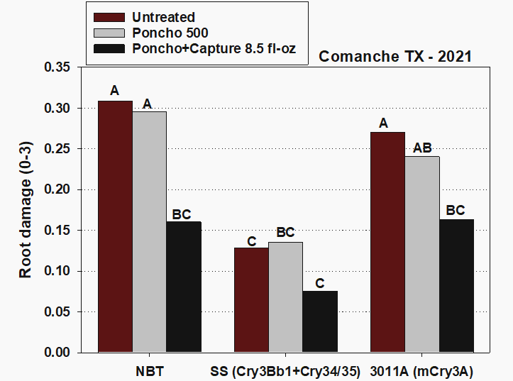
Figure 1. Corn rootworm root damage ratings based on the Iowa State 0-3 Corn Rootworm Damage Rating Scale, Comanche, TX 2021. Treatments with the same letter are not significantly different based on an F-protected LSD(P=0.05).

Percent of roots with less than equal to 0.25 nodes ranged from a low of 45% for the non-Bt alone and Agrisure 3011A trait package alone, to a high of 100% for SmartStax with Poncho 500 and Capture LFR in-furrow (Figure 2). Significant differences were observed between treatments, with the SmartStax trait package with Poncho 500 and Capture LFR having significantly more root masses with less than 0.25 nodes of damage than the non-Bt alone, non-Bt with Poncho 500, the non-Bt with Poncho 500 and Capture LFR, and the Agrisure 3011A trait package with and without the Poncho 500 seed treatment. This data indicates that corn rootworm damage can be significantly reduced by using Bt traits, insecticide seed treatments, and in-furrow insecticides.

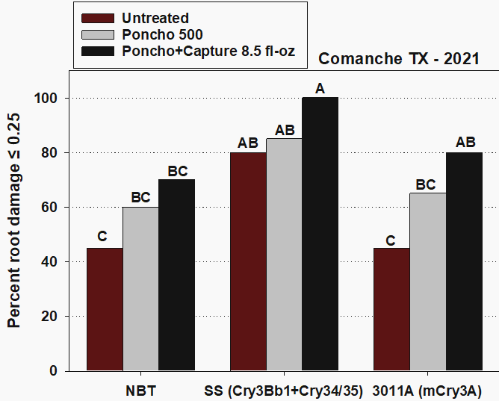
Figure 2. Percent of roots with less than equal to 0.25 nodes pruned to within 1 ½ inches of the stalk at Comanche, TX, 2021. Means with the same letter are not significantly different based on an F-protected LSD(P=0.05).

Conclusions
The corn rootworm pressure experienced at both test locations was very low compared to what was expected. The corn rootworm pressure was likely negatively affected by Winter Storm Uri and the excessive amounts of rainfall experienced during the spring. The results of this trial indicated that corn rootworm damage can be reduced by utilizing Bt traits, insecticide seed treatments, and in-furrow insecticides. Based on these results it is also concluded that in fields with corn rootworm issues planting a trait package with at least 2 below ground Bt proteins is better than no below ground Bt proteins or a single protein trait package. Insecticide seed treatments like Poncho and Cruiser can also be utilized but should be used at the 500 or 1250 rates and can help reduce the amount of root damage in cases where a multi-protein corn rootworm trait package cannot be planted. Additionally, based on this data, in field with severe corn rootworm problems, utilizing a 2-protein Bt trait package may need to have an insecticide seed treatment and in-furrow insecticide to significantly reduce root damage.

Acknowledgements
The authors would like to thank David Westerfeld and Benjamin Volleman for their cooperation and for allowing these trials to be conducted on their farms. We would also like to thank the numerous undergraduate students that helped with data collection. The mentioning of trade names in the paper is for clarity purposes only and does not imply an endorsement by the authors, Texas A&M AgriLife Extension Service, or the Texas A&M University System. This Trial was funded by a Texas Corn Producers Board project.

