Applied Research Report
Efficacy of Belowground Bt Corn Traits Against Mexican and Southern Corn Rootworms, 2021
Authors
D. Tyler Mays, Extension Agent-IPM Hill and McLennan Counties
David Kerns, Extension Specialist-Entomology
Shane McLellan, County Extension Agent-Ag/Nr
Mike Berry, County Extension Agent-Ag/Nr
Zach T. Davis, County Extension Agent-Ag/Nr

Cooperator
Benjamin Volleman
David Westerfeld
Summary
Corn rootworm is a major pest of corn, especially in fields where corn is planted behind corn for multiple years. Two field trials were conducted to evaluate the efficacy of belowground Bt trait packages against the Mexican corn rootworm. Trait packages evaluated included SmartStax, QROME, Agrisure 3011A, and a non-Bt. Treatments were replicated four times in a randomized complete block design, and means were separated using an F-protected LSD(P=0.05). Five plants per plot were dug and rated for corn rootworm damage using the Iowa State 0-3 corn rootworm damage rating scale. No corn rootworm damage was observed at the McLennan County location at the time of sampling. Corn rootworm damage was observed in the Comanche County test, and damage ranged from 0.08 nodes for SmartStax to a high of 0.35 nodes for the non-Bt treatment. The amount of corn rootworm damage was significantly reduced by all Bt trait packages. Based on the results of these tests all CRW Bt trait packages can provide significant protection against Mexican corn rootworm, and there is not apparent resistant issues to the current corn rootworm Bt toxins.

Introduction
Corn rootworm (CRW) is a major pest of corn in the United States of American and damage the plant by feeding on both the nodal root system and silks. In Central Texas the Mexican and Southern CRW are the predominant species, causing damage to corn. Over the last five years crop markets have favored corn production leading to continuous corn planting of some fields which is known to increase issues with CRW damage. There is known resistance to most available CRW Bt traits dating back to 2009, but currently there are no known CRW resistance in Texas. Current management options for CRW in the Texas Blacklands include crop rotation, utilizing CRW Bt trait packages, insecticide seed treatments, and the application of in-furrow insecticides. This field trial was conducted in Comanche and McLennan Counites to evaluate the efficacy of various CRW Bt trait packages against the Mexican corn rootworm.

Materials and Methods
Two field trials were conducted in Comanche and McLennan Counties in Central Texas. The Comanche County location was planted on 8 March 2021, and the McLennan County location was planted on 10 March 2021. Three commercial CRW Bt trait packages SmartStax, QROME< and Agrisure 3011A along with a non-Bt hybrid were utilized for both locations. Treatments were replicated four times in a randomized complete block design. Corn rootworm damage was collected by digging five root masses per plot at the VT (tassel emergence) growth stage. These root masses were washed with a pressure washer to remove all soil, and then the damage was rated using the Iowa State 0-3 Corn Rootworm Damage Scale, where 0 was no damage and 3 was 3 or more complete nodal roots pruned to within 1 ½ inch of the stalk (Table 1). Yield data was collected for the McLennan County, but not the Comanche County location due to it being harvested for silage. All data was analyzed using analysis of variance and means were separated using F-protected LSD(P=0.05).

Table 1. Description of the Iowa State University 0-3 Corn Rootworm Damage Rating Scale
Rating | Description
0 | No feeding damage to root system
1 | One node or the equivalent of an entire node pruned back to approximately 1 1/2 inches to the stalk
2 | Two complete or the equivalent of two nodes of root pruned back to approximately 1 ½ inches to the stalk
3 | Three or more nodes of roots pruned back to approximately 1 ½ inches to the stalk

Results and Discussion
McLennan County
There was no observed CRW feeding damage at the time of sampling, so data was not collected for CRW damage at this location. Plots were harvested and averaged 115 bu./acre across all treatments.

Comanche County
This location did experience damage, but the level of the damage was extremely low. Corn rootworm damage ratings ranged from 0.08 node for SmartStax to a high of 0.35 nodes for the untreated check, with significant differences observed between the non-Bt and all CRW Bt trait packages (Figure 1). All Bt trait packages significantly reduced the amount of root damage caused by CRW compared to the non-Bt, but there was no observed difference between the different CRW Bt trait packages. These damage ratings are very low for a field that has been corn behind corn for multiple years. The percent of root systems with a rating less than 0.25 ranged from 57% in the untreated to a high of 97% in the SmartStax and QROME Bt trait packages (Figure 2). The SmartStax and QROME had significantly more roots with less than 0.25 nodes of damage than the Agrisure 3011A trait package and the non-Bt. This indicates that although the Agrisure 3011A trait package is not as effective at reducing CRW feeding damage as those with two genes.
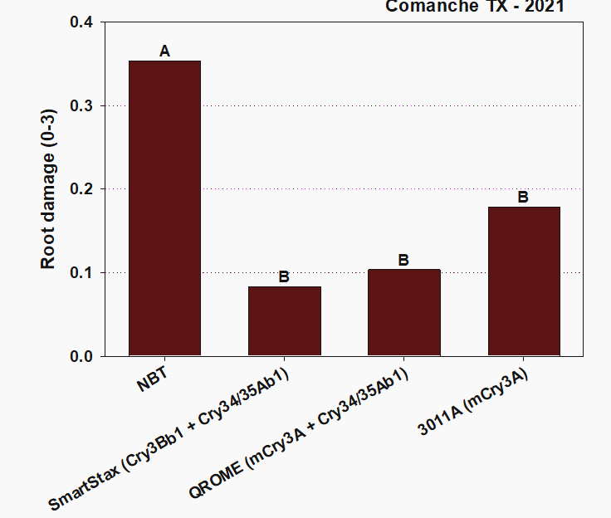
Figure 1. Corn rootworm damage ratings at Comanche County, 2021. Means with the same letter are not statistically different based on a F-protected LSD(P=0.05).

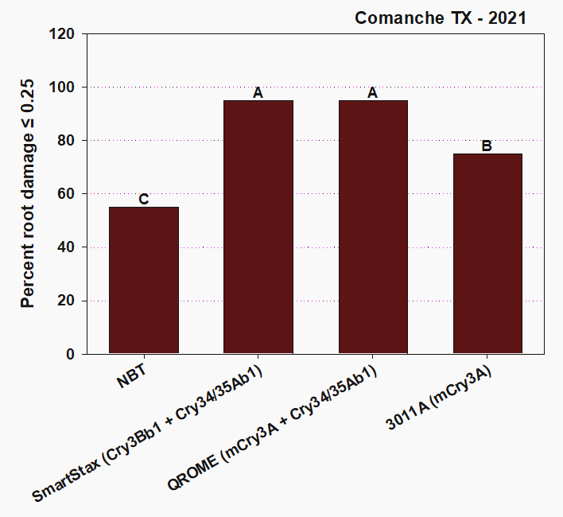
Figure 2. Percent of roots with 0.25 nodes or less pruned at Comanche County, 2021. Means wit the same letter is not statistically different based on an F-protected LSD(P=0.05)

Conclusions
The results of these trials indicate that CRW Bt trait packages can significantly reduce the amount of CRW feeding damage, and that there is no indication of resistance in Mexican corn rootworm populations in Central Texas. However, this year was not great to asses how effective the Bt trait packages are due to the low amount of damage in the non-Bt treatment. This low insect pressure is likely due to the extreme cold weather experience in February due to Winter Storm Uri, and the excessive amounts of rainfall in the spring and early summer. The large amounts of rain led to waterlogged soil conditions likely led to an increase in natural mortality.

Acknowledgements

The authors would like to thank David Westerfeld and Benjamin Vollemann for their cooperation and allow for these trials to be conducted on their farm. We would also like to thank the numerous undergraduate students that helped with data collection. The mentioning of trade names in the paper is for clarity purposes only and does not imply an endorsement by the authors, Texas A&M AgriLife Extension Service, or the Texas A&M University System. This Trial was funded by a Texas Corn Producers Board project.

